Missouri Department of Transportation
Permitting on the Right of Way
Version date 12/1/21

Contents

Contacts 2
Accessing Permitting Application from MoDOT.org 3
Requesting a new permit 5
Permit Status 6
Populating Contact Information 7
Adding New Contact Information for Utility or Contractor 7
Locating Your Permit 8
Manually Selecting Routes for ROW Permits 9
Choosing the Type of Work 11
Adding Attachments 12
Work Description 12
Comments 12
Submitting the Permit 13
Viewing and Updating a Permit 14
Printing a Permit 15
Intent to Work 16
Completed Work 17
No Work Done 17

Contacts

Highway Safety and Traffic
Mindy Grapes-Bess
Phone: 573-751-2822
Email: mindy.grapes-bess@modot.mo.gov

Raymond Shank
Phone: (573) 526-4293
Email: raymond.shank@modot.mo.gov

Transportation Management System

Valerie Minnick
Phone: 573-526-8055
Email: valerie.minnick@modot.mo.gov

Deann Wieberg
Phone: (573) 522-8464
Email: deann.wieberg@modot.mo.gov

Accessing Permitting Application from MoDOT.org

From the www.modot.org homepage, hover the mouse arrow over ‘Doing Business with MoDOT’ then select Permits from the menu.
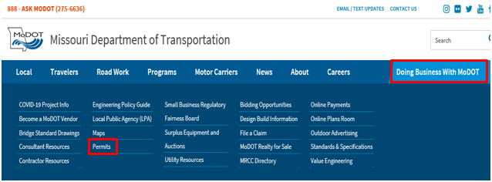

To access the permitting application, click on the link highlighted below
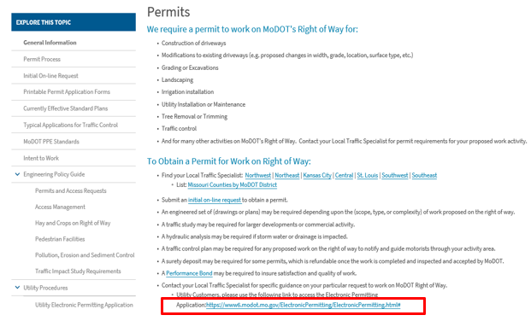

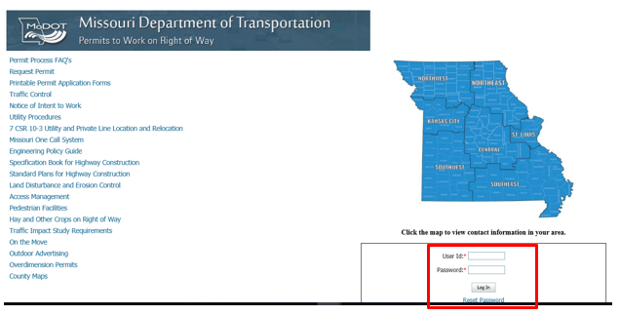

After the user logs in using their credentials, they are directed to the Customer Information page. Users will be able to create; view and update permits

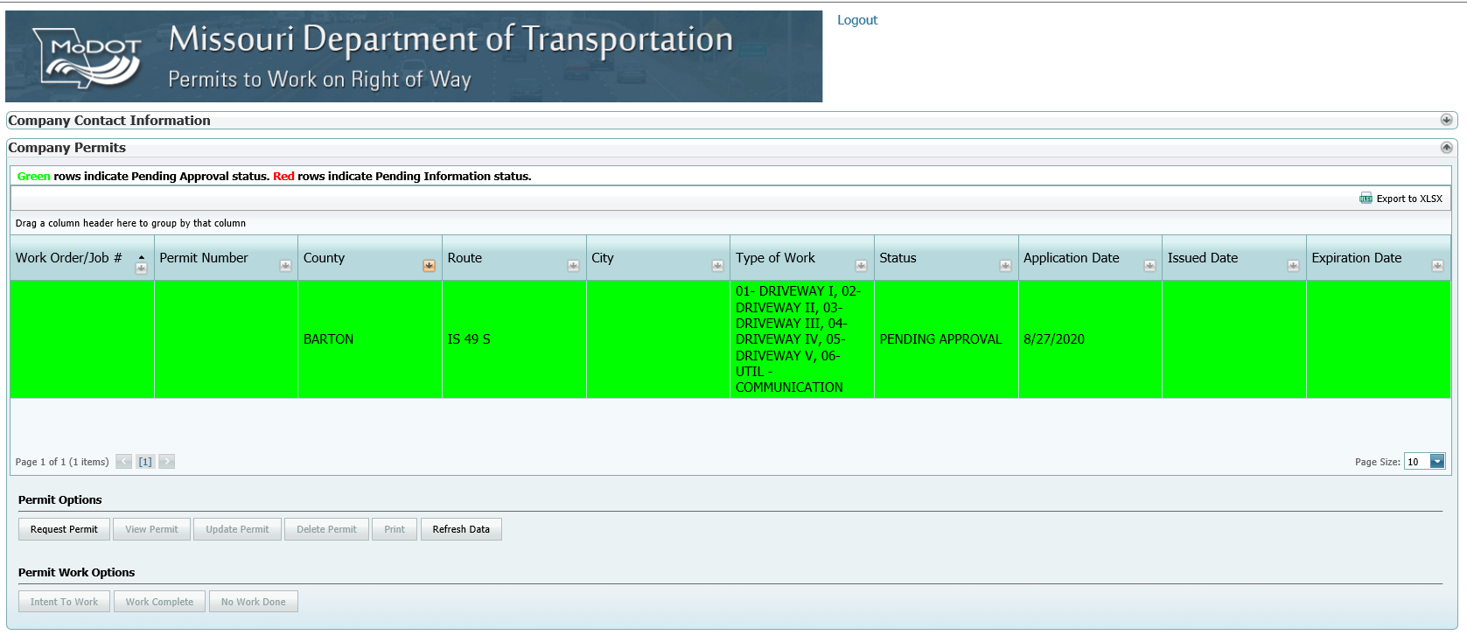
Please note: Green rows indicate Pending Approval status; red rows indicate Pending Information is needed, which can be found in the comments section. Also, the Clear Filters button will clear the column filter selections if needed. 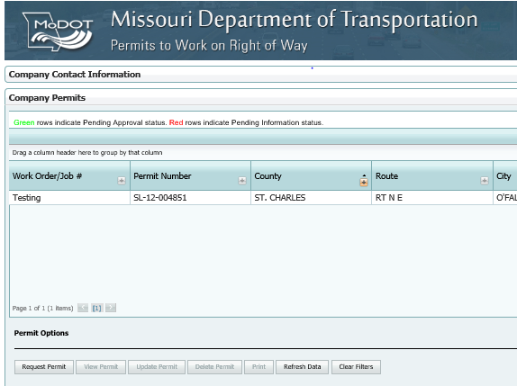

Requesting a new permit

Click on the Request Permit button, under Permit Options
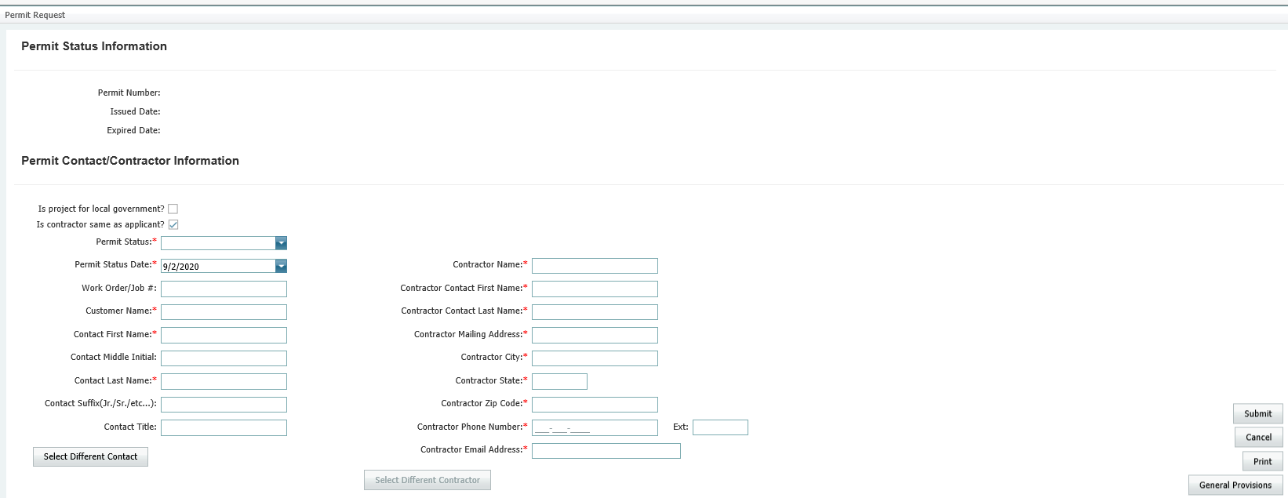

Enter all necessary information in the mandatory fields (marked with a red asterisk)

Important Notes: Select the ‘Is project for local government?’ check box for local government. If contractors are doing the proposed work, the ‘Is contractor same as applicant?’ checkbox will need to be unchecked.
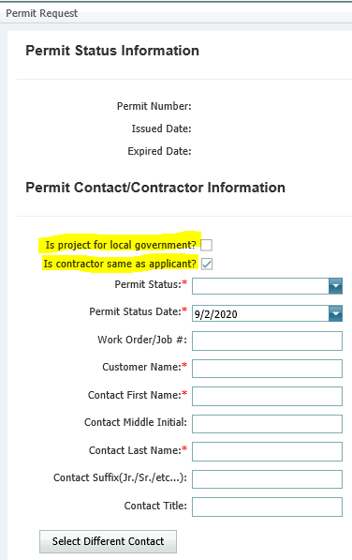

Permit Status

Draft Utility status allows you save and fill out a permit without submitting it for approval.
Pending Approval status will submit the permit for approval after clicking the Submit button at the bottom of the page.
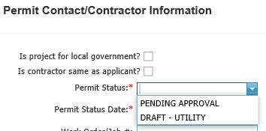

Populating Contact Information

- Select Different Contact to enter contact information.

Adding New Contact Information for Utility or Contractor
- Select Company Contact Information Section above Company Permits Section (ON HOME SCREEN)
- Select New
- 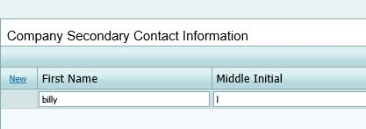
- Enter First, Last name Phone # &/or Cell # and email address
- Select Save Changes
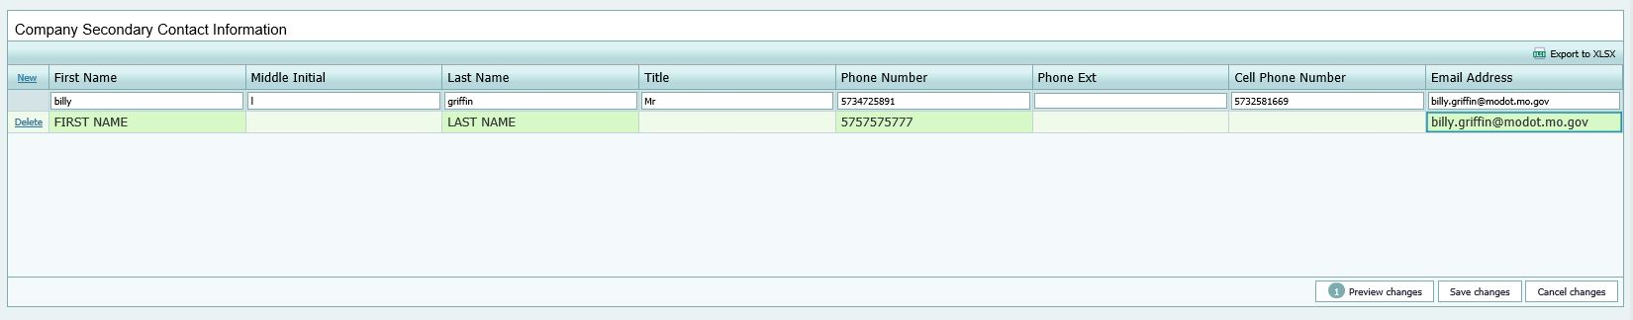

Locating Your Permit

- Users are required to select a county for the proposed work on Right of Way.
- The Load Map button will allow the users to select locations from the Basemap.

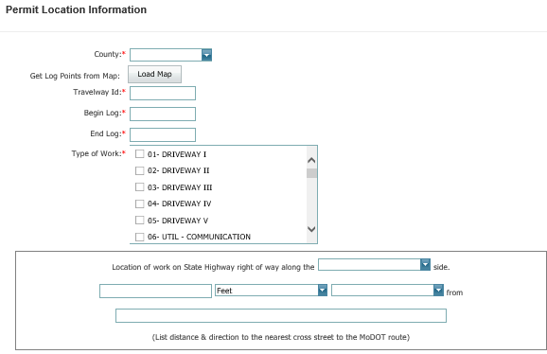

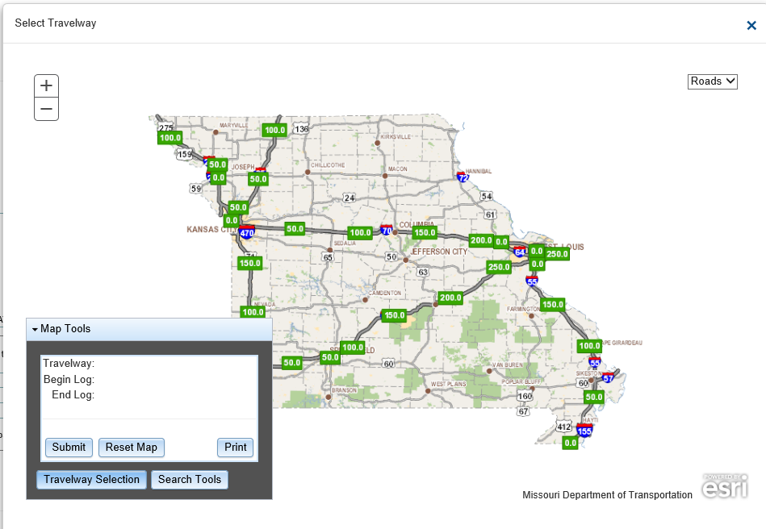
3
2
1
- Zoom In/Out – Along with using the +/- buttons in the top-left, scrolling the mouse wheel forward will zoom into the map, while scrolling back towards the user will zoom the map out.
- Roads/Aerial View – Use the dropdown arrow, to change the view from a Basemap, to an aerial view.
- Map Tools – Manually search for travelways needed for permitting, example, US 63 N, then select the Enter button locate the travelway.
  - Users can also search for Cities and Counties using the Search Tools button or select routes on the map using your mouse.

Important Note: When entering partially completed permits, users need to use the map feature, or the entry will not be saved.

Manually Selecting Routes for ROW Permits

- Zoom into your location
- Select the travelway for the permit request
- Specify which travelway you are requesting:
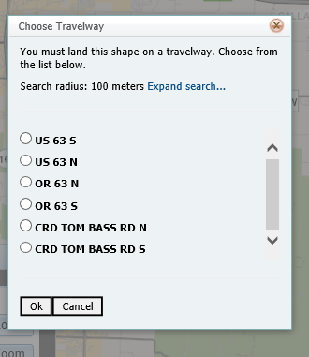

- Select the route using the radio buttons, then select OK
- A green star shows on the route you selected, indicating one point of the permit location. To complete the entry, simply click the map for the opposite point
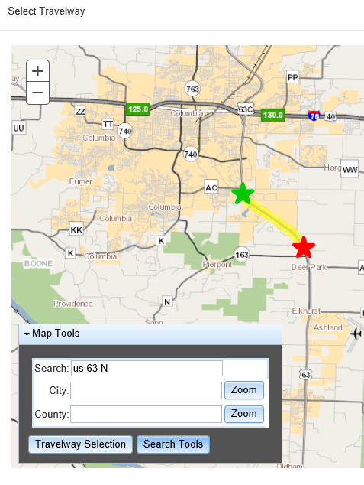

- Under Travelway Selection the log points are available
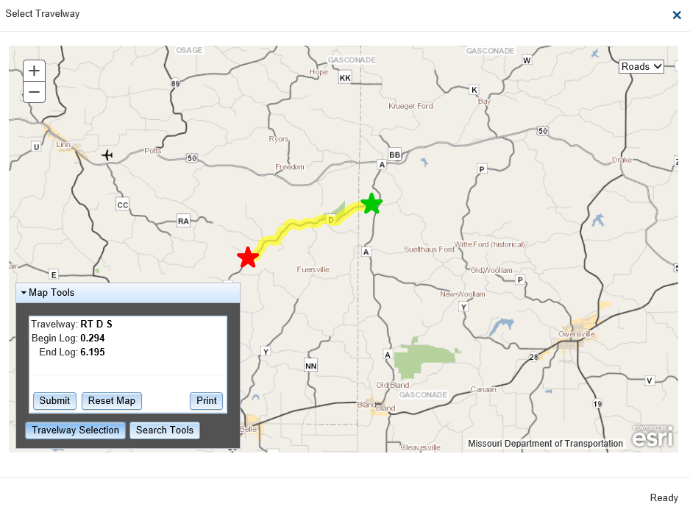

- Click Submit to confirm your location selection

Choosing the Type of Work

Select all the Type of work that is being completed. There are 37 choices available to the user:
01 – Driveway I 17 – Hay 34 – License Plate Reader
02 – Driveway II 18 – HazMat Clean Up 35 – UTIL – SM Cell Pole
03 – Driveway III 19 – Irrigation 36 – UTIL Transport Pole
04 – Driveway IV 20 – Landscaping 37 – Active Signal Work
05 – Driveway V 21 – Levee Attachment
06 – Util Communication 22 – Lighting Highway
07 – Util – Water 23 – Monitoring Wells
08 – Util – Gas 24 – Pedestrian Crossing
09 – Util – Cable 25 – Shift & Widening
10 – Util – Electric 26 – Sidewalks
11 – Util – Sewer 27 – Signals
12 – Excavation 28 – Traffic Control/Detour
13 – Misc/Other 29 – Tree/Brush Removal
14 – Agreements 30 – Railroad
15 – Blasting 31 – Automated Enforcement
16 – Geometric
Improvements 32 ─ Local Rd Improvements
33 ─ Utl Relocation - Mod

Adding Attachments
- After selecting the Location of Work on State Highway right of way, users have the ability to add attachments by selecting Add. Users can upload a single or multiple documents.
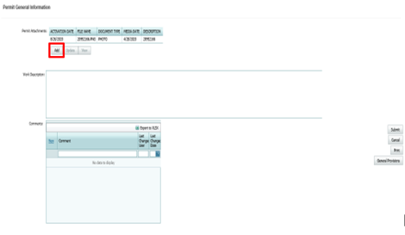

Work Description
Users are required to give a detailed description of the nature of the work being completed.
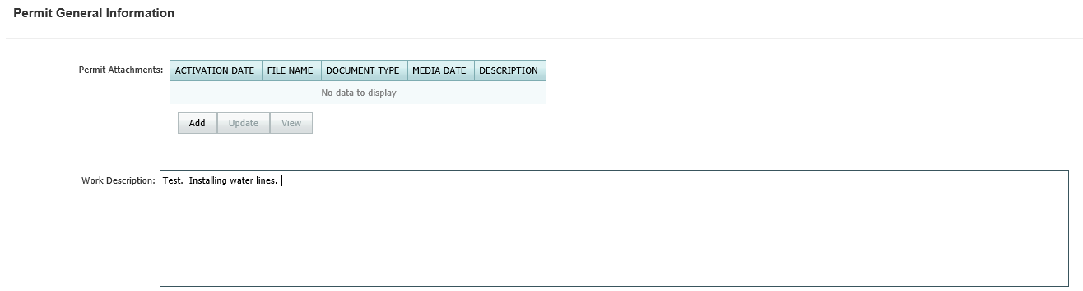

Comments
The Comments section of the online form is used to add any additional information to communicate with the Traffic Specialists regarding changes or additions to the permit by selecting New in the top-left of the comments section
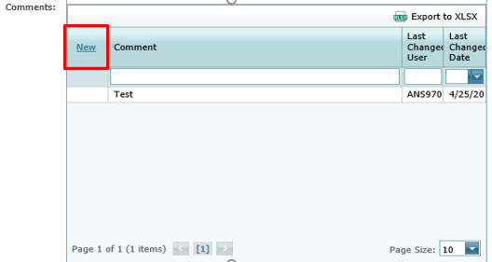

Submitting the Permit

When all comments are submitted and all required fields have been populated, select Submit action button from the right of your screen
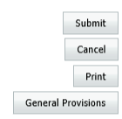

When the permit is submitted successfully, users will receive a confirmation
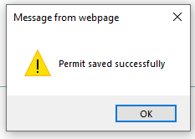

*Important Note*
If the permit is in Draft status, the permit will only be visible in your permit list, will not be submitted to MoDOT.

Viewing and Updating a Permit
To view a permit, select the record from the Company Permits table, then select View Permit. This will open the permit, but not allow any changes to be made
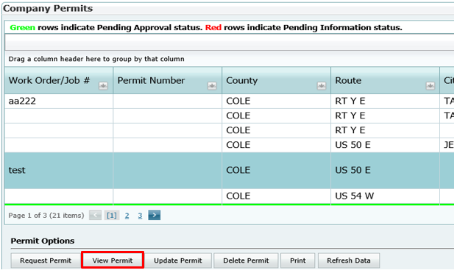

To edit a permit, highlight the record from the Company Permits table, then select Update Permit
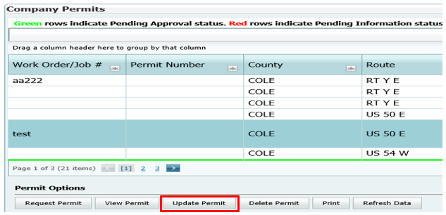
When all information which is required is complete, a MoDOT representative will change the status to Approved. The user will then have the opportunity to accept or not accept the permit. When accepted, MoDOT will be notified, and the updated permit will be issued.

Printing a Permit
To print a permit simply highlight your record, and select the Print button
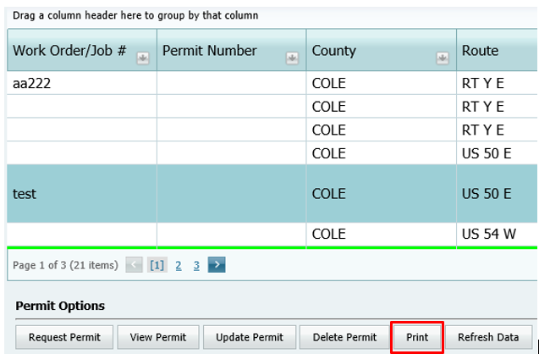

Intent to Work
Once the permit number is assigned, the Intent to Work form is required to move forward.
Three methods of informing MoDOT of the intent to work on MoDOT’s Right of Way (Missouri One Call locate sheets are not a substate). Although, MoDOT’s is a member of Missouri One Call, the information in the fields below is required in order to track work zones, lane drops, shoulder work, traffic control plans, etc.
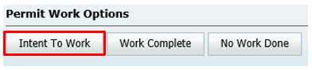
    - Complete all Intent to Work fields, then select Submit. The form will automatically be sent to the correct District Office for processing. This is the preferred method of delivery.
    - Fax – Print the Intent to Work form, complete and fax to the correct District Office fax number, which can be found on the form.
    - Phone – Call 888-275-6636 (ASK MoDOT) or call the District Office number shown and provide the information on the form to the Customer Service Representative.
Notifications should be submitted a minimum of 2 working days and a maximum of 10 working days prior to beginning work.

Completed Work
When work on the Right of Way is complete, highlight the Work Order/Job and select Work Complete from the Permit Work Options selections.
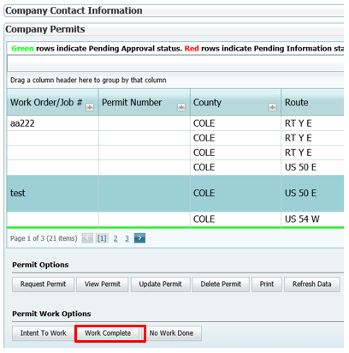
When Work Complete is chosen, a notification will be sent to a MoDOT representative for the work to be inspected. When the work is deemed satisfactory, MoDOT will change the permit status to Released.

No Work Done
If work is not being done, and a permit is already requested, highlight your permit from the list and select No Work Done.
